**Lesson 2 – Tutorial**

1. Amend the following HTML documents.

**Photo.html**

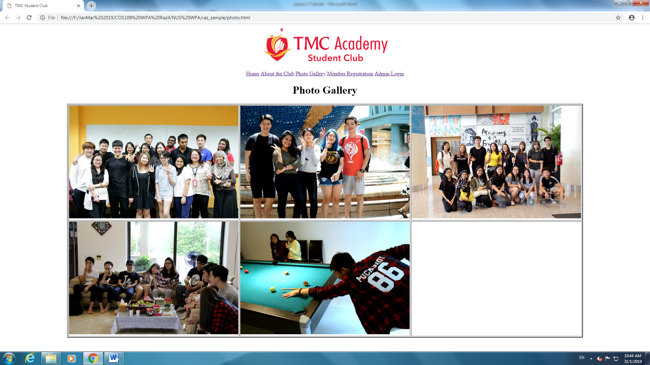

* Create a 3-rows / 3-columns table as shown.
* Insert images in the table as shown.

**Registration.html**

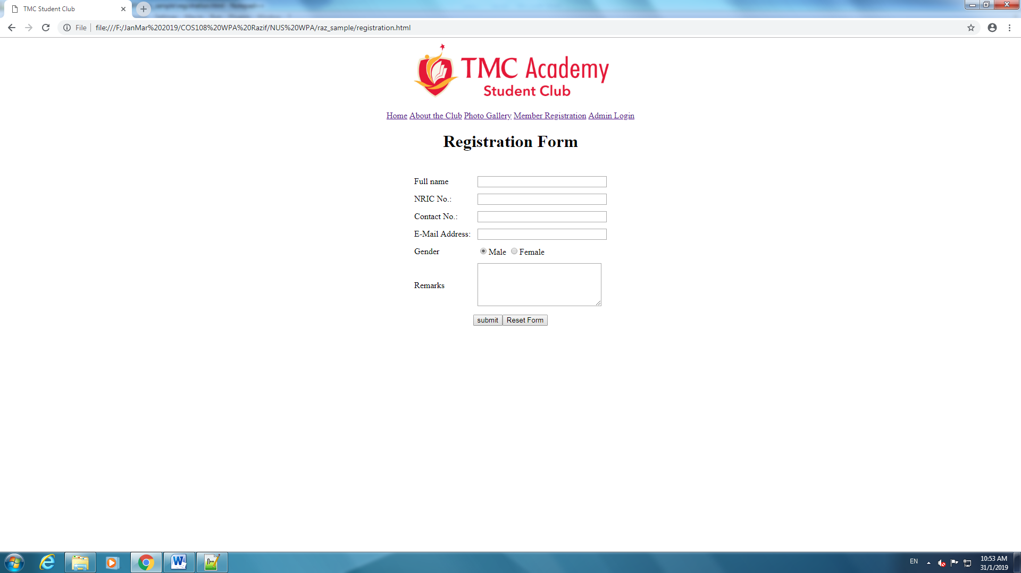

* Create a 7-rows /2-columns table as shown.
* Insert form elements as shown.